Modifier

New popup needed

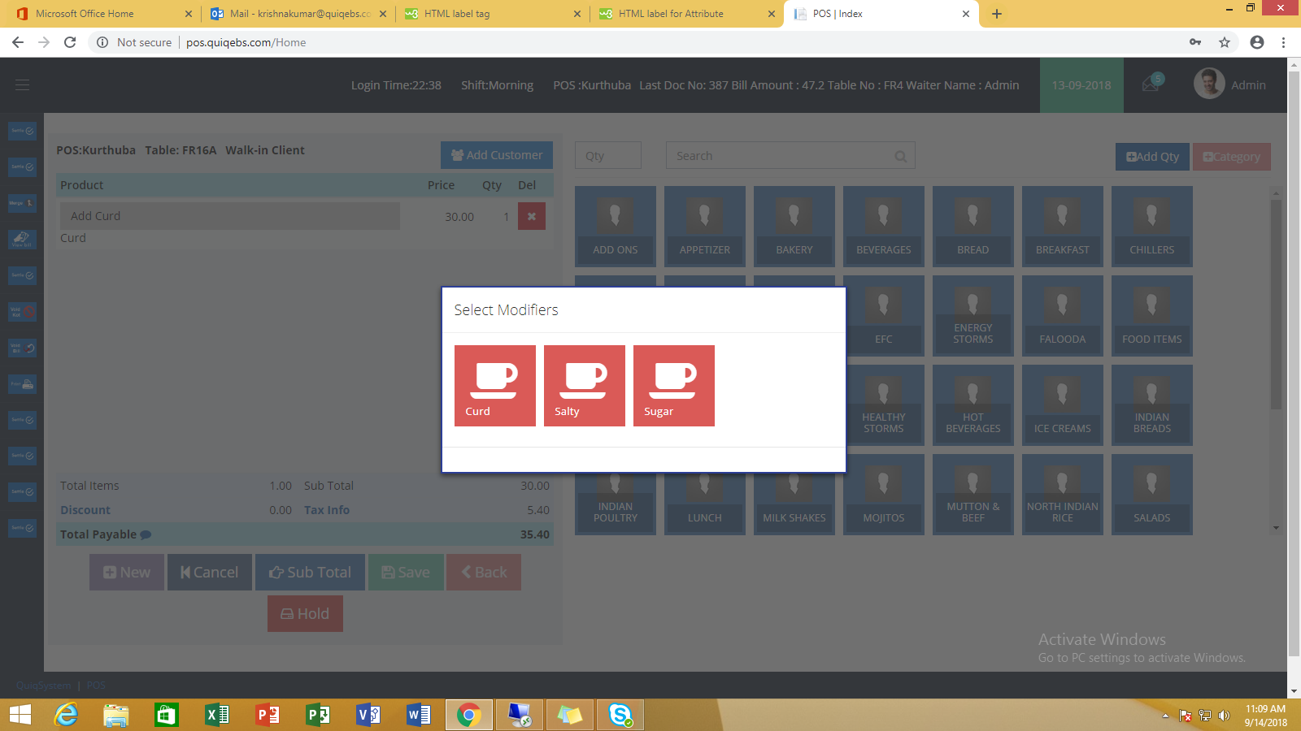

Rate Change

New popup needed

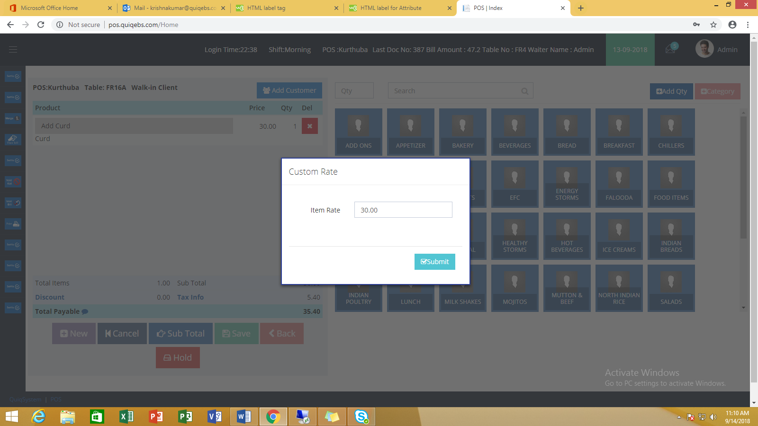

View Bill

Need a new screen similar to this – kendo grid

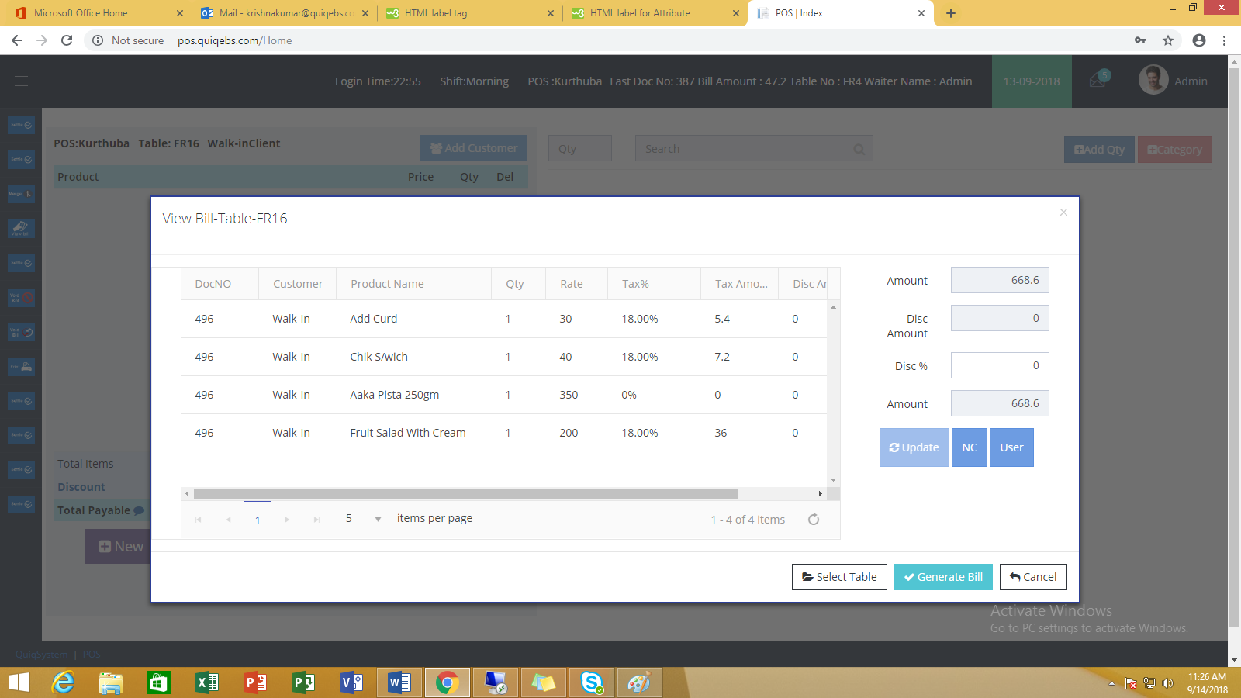

Buttons

Need 2 more buttons to be placed – New , save , back

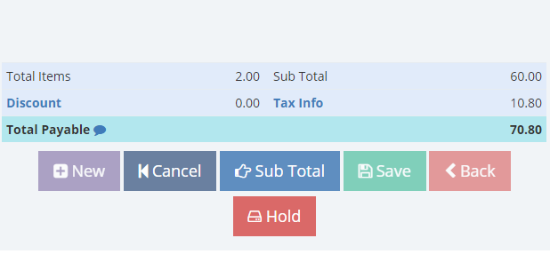

Shift Open

New popup needed

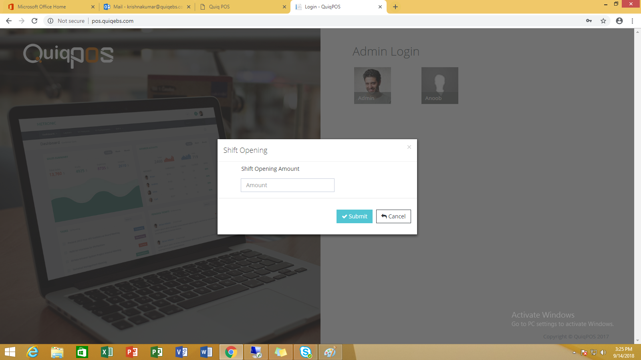

Discount

New popup needed on item click

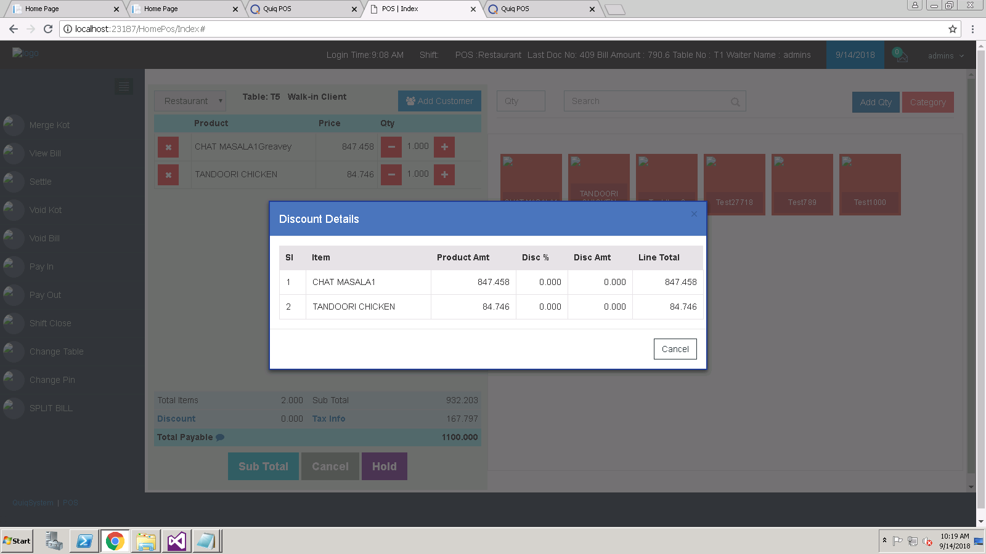

Home View

The design looks creepy when a new order is not yet initialized

